Computer Architecture Lab (EL-2012)
LABORATORY REPORT
Fall 2026


(Lab#1)
Apply modern simulation tools ModelSim and Logisim to implement basic processor components

Student Name: Muhammad Hamza Roll No: 24i-6513 Section: CE-A

Date performed: 8/19/ 2026

MARKS AWARDED / 10

Signature and date of Instructor: _________________
Lab Instructors: Dr. Nasir Ali Shah, Engr. Fasih Ahmad

NATIONAL UNIVERSITY OF COMPUTER AND EMERGING SCIENCES, ISLAMABAD

Prepared by: | Fasih Ahmad | Version: 1.0
Verified by: | Dr. Nasir Ali Shah | Updated: Fall 2026

Task 1:
Description:
In these 7 codes we first made a module logicgate that define the inputs and the outputs, we define the variables that indicate the input and then the output, then we performed the operation such as AND, OR, NOR, NAND etc. Then we made a module testmatch that basically gives the input s and then tests the output accordingly and also, we
put a #50 as the delay. And then we compiled it and then we simulated it and saw the waveforms accordingly.
Code:
 | AND  module logicgate(a,b,c); input a ;  input b; output c;  and a1(c,a,b); endmodule  module testmatch(); reg x;  reg y; wire z;  logicgate aut(x,y,z); initial  begin  x = 0; y = 0;  #50  x = 0; y = 1;  #50  x = 1; y = 0;  #50  x = 1; y = 1;  end endmodule | OR  module logicgate(a,b,c); input a ;  input b; output c;  or a1(c,a,b); endmodule  module testmatch(); reg x;  reg y; wire z;  logicgate aut(x,y,z); initial  begin  x = 0; y = 0;  #50  x = 0; y = 1;  #50  x = 1; y = 0;  #50  x = 1; y = 1;  end endmodule | NAND  module logicgate(a,b,c); input a ;  input b; output c;  nand a1(c,a,b); endmodule  module testmatch(); reg x;  reg y; wire z;  logicgate aut(x,y,z); initial  begin  x = 0; y = 0;  #50  x = 0; y = 1;  #50  x = 1; y = 0;  #50  x = 1; y = 1;  end endmodule

 | NOR  module logicgate(a,b,c); input a ;  input b; output c;  nor a1(c,a,b); endmodule  module testmatch(); reg x;  reg y; wire z;  logicgate aut(x,y,z); initial  begin  x = 0; y = 0;  #50  x = 0; y = 1;  #50  x = 1; y = 0;  #50  x = 1; y = 1;  end endmodule | XOR  module logicgate(a,b,c); input a ;  input b; output c;  xor a1(c,a,b); endmodule  module testmatch(); reg x;  reg y; wire z;  logicgate aut(x,y,z); initial  begin  x = 0; y = 0;  #50  x = 0; y = 1;  #50  x = 1; y = 0;  #50  x = 1; y = 1;  end endmodule | XNOR  module logicgate(a,b,c); input a ;  input b; output c;  xnor a1(c,a,b); endmodule  module testmatch(); reg x;  reg y; wire z;  logicgate aut(x,y,z); initial  begin  x = 0; y = 0;  #50  x = 0; y = 1;  #50  x = 1; y = 0;  #50  x = 1; y = 1;  end endmodule
NOT
AND
module logicgate(a,c); input a ;
output c;

not a1(c,a);
endmodule
module testmatch(); reg x;
wire z;
logicgate aut(x,z); initial
begin
x = 0;
#50
x = 1;
end endmodule
Output:
AND

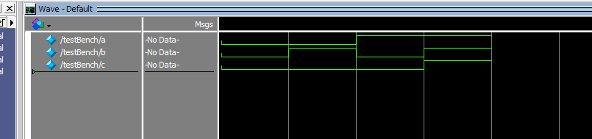

NAND

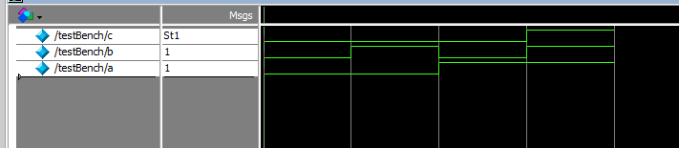

OR

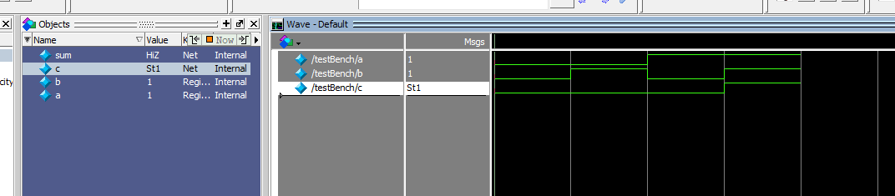

NOR

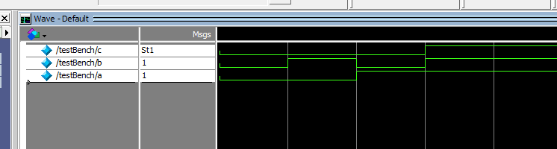

NOT

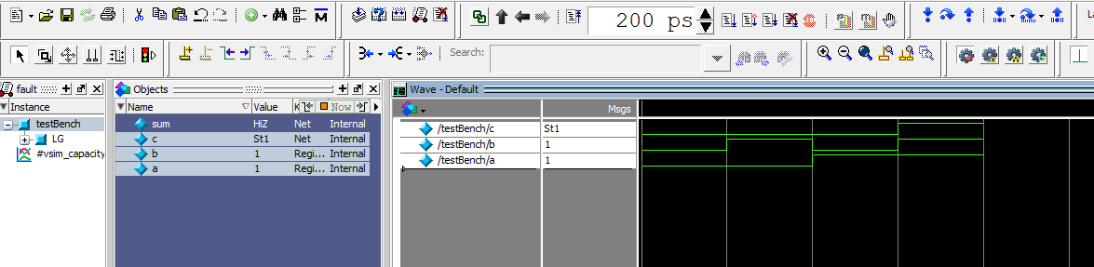

XOR
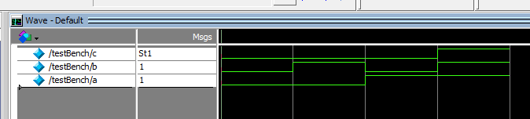
XNOR

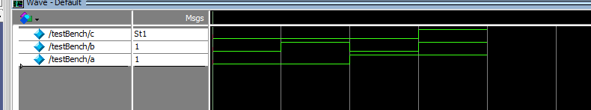

Task 2:

Description:
Each of the seven programs follows a consistent layout comprising two modules: logicgate for port definitions and testmatch for validating gate operations using toggling inputs. The primary distinction here is the implementation of dataflow modeling, which relies on the standard operator syntax provided in the lab manual table.
Code:
 | AND  module logicgate(a,b,c); input a;  input b; output c;  assign c = a & b; endmodule  module testmatch(); reg x;  reg y; wire z;  logicgate aut(x,y,z);  initial begin  x = 0; y = 0;  #50  x = 0; y = 1;  #50  x = 1; y = 0;  #50 | OR  module logicgate(a,b,c); input a;  input b; output c;  assign c = a | b; endmodule  module testmatch(); reg x;  reg y; wire z;  logicgate aut(x,y,z); initial  begin  x = 0; y = 0;  #50  x = 0; y = 1;  #50 | NAND  module logicgate(a,b,c); input a;  input b; output c;  assign c = ~(a & b); endmodule  module testmatch(); reg x;  reg y; wire z;  logicgate aut(x,y,z); initial  begin  x = 0; y = 0;  #50  x = 0; y = 1;  #50

 | x = 1; y = 1;  end endmodule | x = 1; y = 0;  #50  x = 1; y = 1;  end endmodule | x = 1; y = 0;  #50  x = 1; y = 1;  end endmodule
 | NOR  module logicgate(a,b,c); input a;  input b; output c;  assign c = ~(a | b); endmodule  module testmatch(); reg x;  reg y; wire z;  logicgate aut(x,y,z); initial  begin  x = 0; y = 0;  #50  x = 0; y = 1;  #50  x = 1; y = 0;  #50 | XOR  module logicgate(a,b,c); input a;  input b; output c;  assign c = a ^ b; endmodule  module testmatch(); reg x;  reg y; wire z;  logicgate aut(x,y,z); initial  begin  x = 0; y = 0;  #50  x = 0; y = 1;  #50  x = 1; y = 0;  #50 | XNOR  module logicgate(a,b,c); input a;  input b; output c;  assign c = ~(a ^ b); endmodule  module testmatch(); reg x;  reg y; wire z;  logicgate aut(x,y,z); initial  begin  x = 0; y = 0;  #50  x = 0; y = 1;  #50  x = 1; y = 0;  #50

 | x = 1; y = 1;  end endmodule | x = 1; y = 1;  end endmodule | x = 1; y = 1;  end endmodule
NOT

module logicgate(a,c); input a;
output c; assign c = ~a; endmodule
module testmatch(); reg x;
wire z;

logicgate aut(x,z); initial
begin

x = 0;

#50

x = 1;
end endmodule
Output:
AND
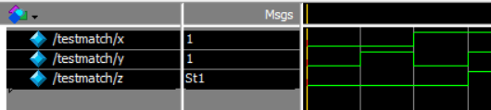

OR
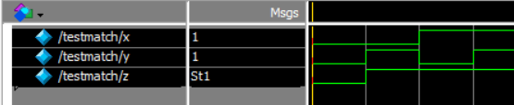
NAND
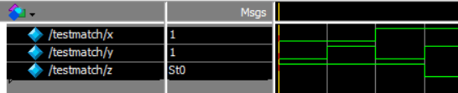
NOR
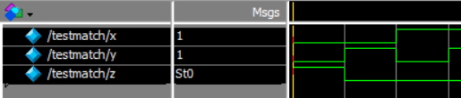
XOR
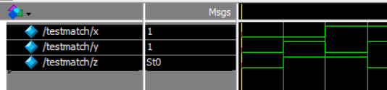
XNOR
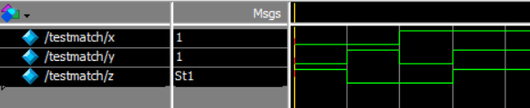
NOT
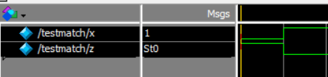

Task 3:

Description:
In this task I basically drew all the seven logic gates in logismin one go meaning keeping the inputs and then checking them simultaneously with keeping the inputs 00 , 01 , 10 , 11.

Code:

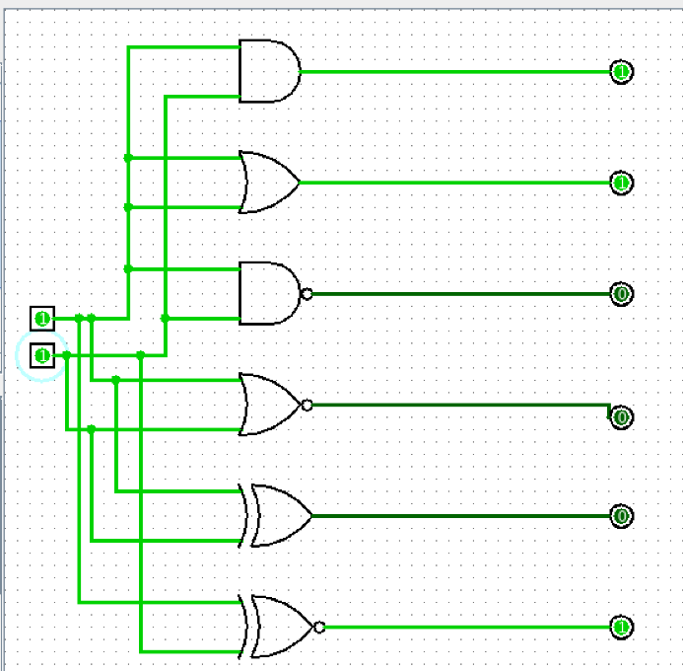
Task 4:

Description:
In this circuit, we have two inputs A and B and one output C, so we take two inputs and one output in the logic gate module logicgate.The wires X and Y connect the outputs of the NOT gates to the AND gates, while z1 and z2 connect the outputs of the AND gates to the OR gate.The OR gate takes z1 and z2 as its inputs and gives the final output C, and the test bench is basically sameas we have 2 inputs.
Code:
module logicgate(a,b,c); input a;

input b; output c; wire x; wire y; wire z1; wire z2; not a1(x,a);
not a2(y,b);

and a3(z1,x,b);

and a4(z2,a,y);

or a5(c,z1,z2); endmodule
module testmatch(); reg x;
reg y; wire z;
logicgate aut(x,y,z); initial
begin

x = 0; y = 0;

#50

x = 0; y = 1;
#50

x = 1; y = 0;
#50

x = 1; y = 1;
end endmodule

OUTPUT:

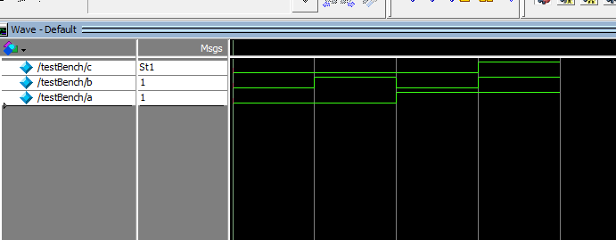

Task 5:

Description:
In this task, we implemented the circuit from Task 4 directly in Logisim, verified it against all input combinations (00, 01, 10, 11), and included the corresponding output screenshots.

Output:

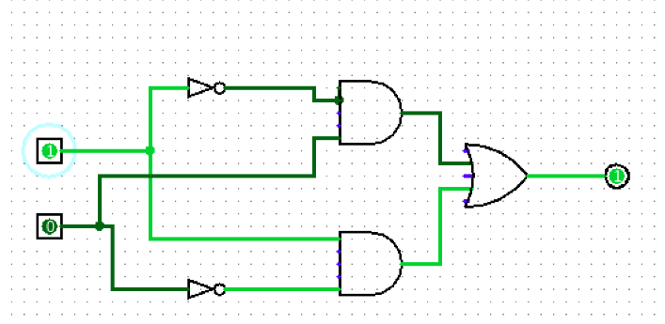

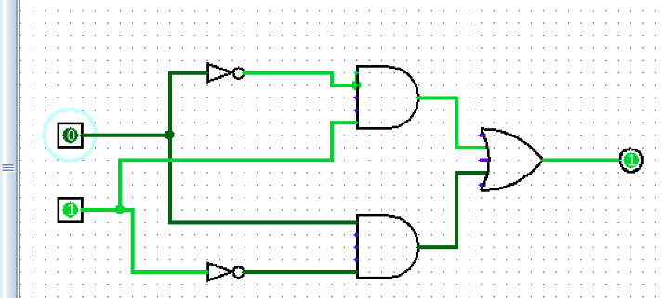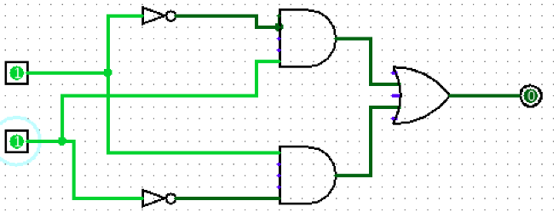

TASK 6

Description:
To implement a 1's complement, we invert the inputs using simple NOT gates for 4-bit outputs. At the gate level, we use explicit NOT gates, whereas at the dataflow level, we use the assign keyword with bitwise inversion. Instead of hardcoding values for all 4 bits, we use a for loop with an integer variable in the testbench for efficiency.
Code:

 | Gate Level Code | Data flow level Code
 | module logicgate (a,b,c,d,w,x,y,z); | module logicgate (a,b,c,d,w,x,y,z);
 | input a,b,c,d; | input a,b,c,d;
 | output w,x,y,z ; | output w,x,y,z ;
 | not a1(w,a); | assign w = ~a;
 | not a2(x,b); | assign x = ~b;
 | not a3(y,c); | assign y = ~c;
 | not a4(z,d); | assign z = ~d;
 | endmodule | endmodule
 | module testbench(); | module testbench();
 | reg a; | reg a;
 | reg b; | reg b;
 | reg c; | reg c;
 | reg d; | reg d;
 | wire w; | wire w;
 | wire x; | wire x;
 | wire y; | wire y;
 | wire z; | wire z;
 | integer i; | integer i;
 | logicgate aut(a,b,c,d,w,x,y,z); | logicgate aut(a,b,c,d,w,x,y,z);
 | initial | initial
 | begin | begin
 | for(i=0; i<16; i=i+1) | for(i=0; i<16; i=i+1)
 | begin | begin

 | {a,b,c,d} = i; | {a,b,c,d} = i;
 | #50; | #50;
 | end | end
 | end | end
 | endmodule | endmodule

OUTPUT:
Data flow level

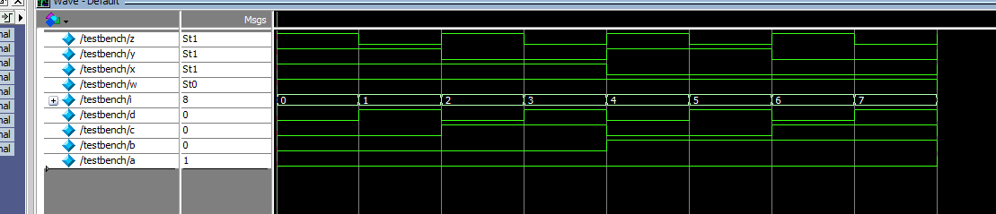
Gate level

